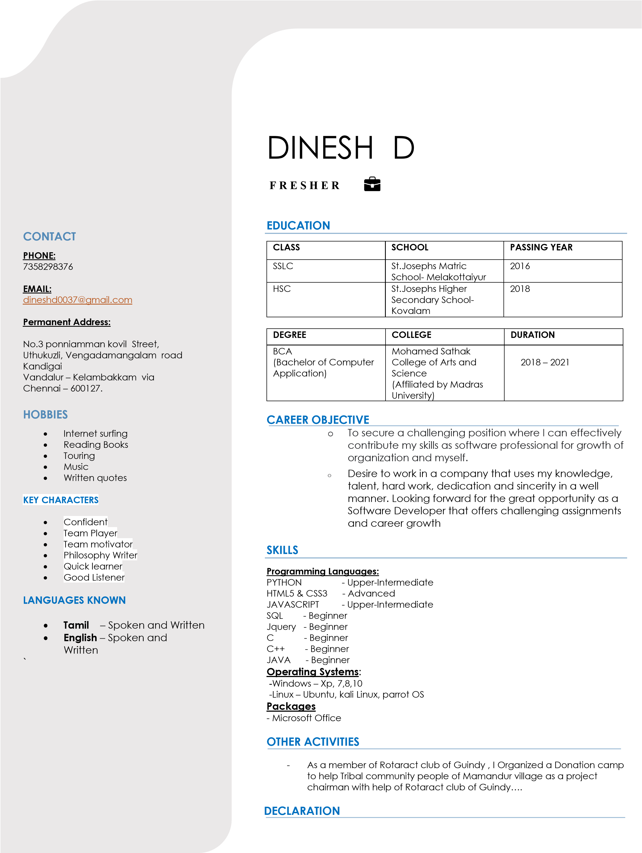

*I hereby*

*inform*

*that the information furnished above is true*

*.*